WAP to add two numbers using single inheritance. Accept these two numbers from the user in base class and display the sum of these two numbers in derived class.
35).

#include <iostream>
using namespace std;

// Base class
class Numbers {
protected:
int num1, num2;
public:
void inputNumbers() {
cout << "Enter first number: ";
cin >> num1;
cout << "Enter second number: ";
cin >> num2;
}
};
// Derived class
class Sum : public Numbers {
public:
void displaySum() {
int sum = num1 + num2;
cout << "The sum of " << num1 << " and " << num2 << " is: " << sum << endl;
}
};

int main() {
Sum obj;
obj.inputNumbers(); // Calling base class function
obj.displaySum(); // Calling derived class function
return 0;
}
- Output:
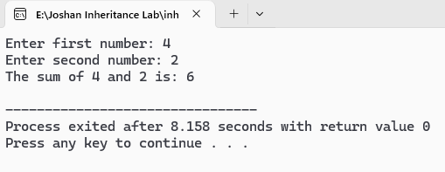

WAP to calculate percentages of a student using multilevel inheritance. Accept the marks of three subjects in base class. A class will derive from above mentioned class which includes a function to find total marks obtained and another class derived from this class calculates and displays percentages of students.
36).
#include <iostream>
using namespace std;

// Base class
class Marks {
protected:
float m1, m2, m3;
public:
void getMarks() {
cout << "Enter marks for Nepali: ";
cin >> m1;
cout << "Enter marks for Science: ";
cin >> m2;
cout << "Enter marks for Mathematics: ";
cin >> m3;
}
};
// Derived class for total
class Total : public Marks {
protected:
float total;
public:
void calcTotal() {
total = m1 + m2 + m3;
}
};
// Derived class to Calculate and display percentage
class Percentage : public Total {
public:
void showPercentage() {
float percent = (total / 300) * 100; // assuming each subject total 100
cout << "\nTotal Marks = " << total;
cout << "\nPercentage = " << percent << "%" << endl;
}
};

int main() {
Percentage student;
student.getMarks(); // Marks
student.calcTotal(); // Total
student.showPercentage(); // Percentage

return 0;
}

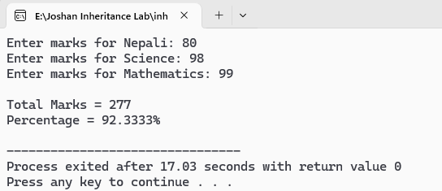
- Output:

Define a student class (with necessary constructors and member functions) in Object Oriented Programming (abstract necessary attributes and their types). (Write a complete code in C++ programming language).
37).
Derive a Computer Science and Mathematics class from student class adding necessary attributes (at least three subjects).
Use these classes in a main function and display the averages marks of computer science and mathematics students.
#include <iostream>
#include <string>
using namespace std;

// Base Class: Student
class Student {
protected:
string name;
int rollNo;
public:
Student(string n, int r) { // Constructor
name = n;
rollNo = r;
}
void showInfo() {
cout << "Name: " << name << "\nRoll No: " << rollNo << endl;
}
};
// Derived Class: Computer Science Student
class ComputerScience : public Student {
private:
float programming, dataStructures, networking;
public:
ComputerScience(string n, int r, float p, float d, float net) : Student(n, r) {
programming = p;
dataStructures = d;
networking = net;
}
float averageMarks() {
return (programming + dataStructures + networking) / 3;
}
};

// Derived Class: Mathematics Student
class Mathematics : public Student {
private:
float algebra, calculus, statistics;
public:
Mathematics(string n, int r, float a, float c, float s) : Student(n, r) {
algebra = a;
calculus = c;
statistics = s;
}
float averageMarks() {
return (algebra + calculus + statistics) / 3;
}
};
int main() {
string name;
int roll;
float m1, m2, m3;
// Input for Computer Science student
cout << "\nEnter Computer Science Student details:\n";
cout << "Name: ";
cin.ignore();
getline(cin, name);
cout << "Roll No: ";
cin >> roll;
cout << "Marks in Programming: ";
cin >> m1;
cout << "Marks in Data Structures: ";
cin >> m2;
cout << "Marks in Networking: ";
cin >> m3;

ComputerScience csStudent(name, roll, m1, m2, m3);
// Input for Mathematics student
cout << "\nEnter Mathematics Student details:\n";
cin.ignore();
cout << "Name: ";
getline(cin, name);
cout << "Roll No: ";
cin >> roll;
cout << "Marks in Algebra: ";
cin >> m1;
cout << "Marks in Calculus: ";
cin >> m2;
cout << "Marks in Statistics: ";
cin >> m3;
Mathematics mathStudent(name, roll, m1, m2, m3);
// Output
cout << "\n------Computer Science Student ------\n";

csStudent.showInfo();
cout << "Average Marks: " << csStudent.averageMarks() << endl;
cout << "\n--- Mathematics Student ---\n";
mathStudent.showInfo();
cout << "Average Marks: " << mathStudent.averageMarks() << endl;
return 0;
}

- Output:
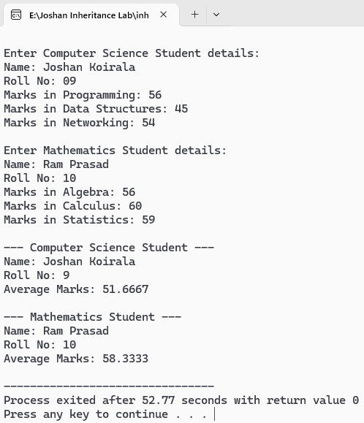

Define a clock class (with necessary constructors and member functions) in Object Oriented Programming (abstract necessary attributes and their types).
38).
Derive a wall_clock class from clock class adding necessary attributes.
Create two objects of wall_clock class with all initial state to 0 or NULL.).
#include <iostream>
#include <string>
using namespace std;

// Base class: Clock
class Clock {
protected:
int hour;
int minute;
int second;
public:
// Default constructor
Clock () {
hour = 0;
minute = 0;
second = 0;
}
// Parameterized constructor
Clock (int h, int m, int s) {
hour = h;
minute = m;
second = s;
}
void showTime() {
cout << "Time: " << hour << ":" << minute << ":" << second << endl;
}
};
// Derived class: WallClock
class WallClock : public Clock {
private:
string brand;
string color;
public:
// Default constructor
WallClock() : Clock() {
brand = "";
color = "";
}
// Parameterized constructor
WallClock(int h, int m, int s, string b, string c) : Clock(h, m, s) {

brand = b;
color = c;
}
void showClock() {
cout << "Wall Clock Details:\n";
showTime();
cout << "Brand: " << (brand.empty() ? "NULL" : brand) << endl;
cout << "Color: " << (color.empty() ? "NULL" : color) << endl;
cout << "-----------------------\n";
}
};
int main() {
// Two wall clock objects initialized with 0/NULL
WallClock clock1;
WallClock clock2;
cout << "--- 1st wall Clock ---\n";
clock1.showClock();
cout << "--- 2nd Clock---\n";
clock2.showClock();
return 0;
}
- Output:
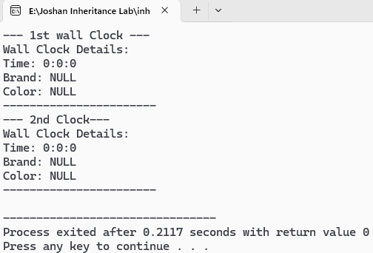

Create a class called lecture that stores ID and name of lectures. From this class derive two classes: part time which adds pay per hr (type float); and full time, which adds pay per month (type float). Each
39).
of these three classses should have readdata() function to get its data from user. Its should have printdata to display data as well. Create object of derived classes to input and display all details.
#include <iostream>
#include <string>
using namespace std;

// Base Class: Lecture
class Lecture {
protected:
int id;
string name;
public:
// Function to read base details
void readdata() {
cout << "Enter Lecture ID: ";
cin >> id;
cin.ignore(); // clear newline from buffer
cout << "Enter Lecture Name: ";
getline(cin, name);
}
// Function to print base details
void printdata() {
cout << "Lecture ID: " << id << endl;
cout << "Lecture Name: " << name << endl;
}
};
// Derived Class: PartTime inherits Lecture
class PartTime : public Lecture {
private:
float payPerHour;
public:
void readdata() {
// Call base class function
Lecture::readdata();
cout << "Enter Pay Per Hour: ";
cin >> payPerHour;
}

// Function to print part time details
void printdata() {
Lecture::printdata();

cout << "Pay Per Hour: " << payPerHour << endl;
}
};
// Derived Class: FullTime
class FullTime : public Lecture {
private:
float payPerMonth;
public:
// Function to read full time details
void readdata() {
Lecture::readdata();
cout << "Enter Pay Per Month: ";
cin >> payPerMonth;
}
// Function to print full time details
void printdata() {
Lecture::printdata();
cout << "Pay Per Month: " << payPerMonth << endl;
}
};

int main() {
// Create objects of derived classes
PartTime partTimeLecture;
FullTime fullTimeLecture;
cout << "--- Enter Part Time Lecture Details ---\n";
partTimeLecture.readdata();
cout << "\n--- Enter Full Time Lecture Details ---\n";
fullTimeLecture.readdata();
cout << "\n--- Part Time Lecture Info ---\n";
partTimeLecture.printdata();
cout << "\n--- Full Time Lecture Info ---\n";
fullTimeLecture.printdata();
return 0;
}

- Output:
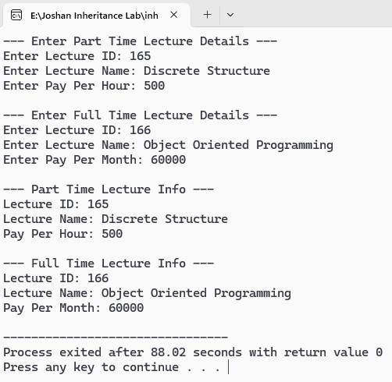

WAP to show access to private, public and protected using different modes of inheritances.
40).

#include <iostream>
using namespace std;

class Base {
private:
int a; // private
protected:
int b; // protected
public:
int c; // public

Base() {
a = 1;
b = 2;
c = 3;
}
};
// Public Inheritance
class DerivedPublic : public Base {
public:
void show() {
// a; // private not accessible
cout << "Public Inheritance - b: " << b << " c: " << c << endl;
}
};

// Protected Inheritance
class DerivedProtected : protected Base {
public:
void show() {
cout << "Protected Inheritance - b: " << b << " c: " << c << endl;
}
};

// Private Inheritance
class DerivedPrivate : private Base {
public:
void show() {

cout << "Private Inheritance - b: " << b << " c: " << c << endl;
}
};

int main() {
DerivedPublic obj1;
obj1.show();
cout << "Access c from public obj1: " << obj1.c << endl; // Public in public inheritance

DerivedProtected obj2;
obj2.show();
// cout << obj2.c; // Not accessible (became protected)

DerivedPrivate obj3;
obj3.show();
// cout << obj3.c; // Not accessible (became private)

return 0;
}

- Output:
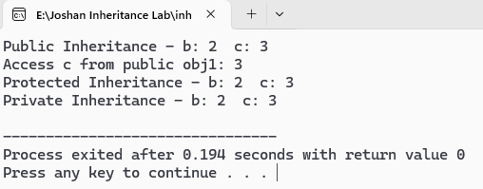

WAP to enter and display details of students of different stream using hierarchial inheritance.
41).
#include <iostream>
#include <string>
using namespace std;

// Base class
class Student {
protected:
string name;
int rollNo;
public:
void readStudent() {
cout << "Enter name: ";
cin.ignore();
getline(cin, name);
cout << "Enter roll number: ";
cin >> rollNo;
}

void displayStudent() {
cout << "Name: " << name << "\nRoll No: " << rollNo << endl;
}
};

// Derived class Science
class ScienceStudent : public Student {
private:
int physics, chemistry, math;
public:
void readScience() {
readStudent();
cout << "Enter Physics marks: ";
cin >> physics;
cout << "Enter Chemistry marks: ";
cin >> chemistry;
cout << "Enter Math marks: ";
cin >> math;
}
void displayScience() {
displayStudent();

cout << "Physics: " << physics << "\nChemistry: " << chemistry << "\nMath: " << math << endl;
}
};

// Derived class Commerce
class CommerceStudent : public Student {
private:
int accounts, business, economics;
public:
void readCommerce() {
readStudent();
cout << "Enter Accounts marks: ";
cin >> accounts;
cout << "Enter Business Studies marks: ";
cin >> business;
cout << "Enter Economics marks: ";
cin >> economics;
}

void displayCommerce() {
displayStudent();
cout << "Accounts: " << accounts
<< "\nBusiness Studies: " << business
<< "\nEconomics: " << economics << endl;
}
};

int main() {
ScienceStudent s1;
CommerceStudent c1;

cout << "--- Enter Science Student Details ---" << endl;
s1.readScience();

cout << "\n--- Enter Commerce Student Details ---" << endl;
c1.readCommerce();

cout << "\n--- Science Student Details ---" << endl;
s1.displayScience();

cout << "\n--- Commerce Student Details ---" << endl;
c1.displayCommerce();

return 0;
}
- Output:

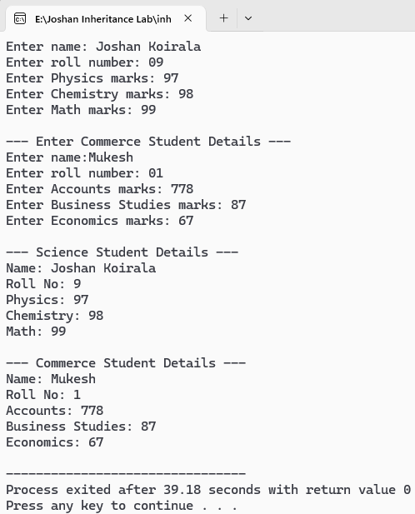
WAP to find the area and volume using multiple inheritance.
42).
#include <iostream>
using namespace std;

// Base class 1
class Area {
protected:
float length, breadth;
public:
void getdata() {
cout << "Enter length: ";
cin >> length;
cout << "Enter breadth: ";
cin >> breadth;
}
float calcArea() {
return length * breadth;
}
};

// Base class 2
class Volume {
protected:
float height;
public:
void getdata() {
cout << "Enter height: ";
cin >> height;
}
float calcVolume(float l, float b) {
return l * b * height;
}
};

// Derived class
class Result : public Area, public Volume {
public:
void display() {
cout << "\nArea of rectangle: " << calcArea();
cout << "\nVolume of cuboid: " << calcVolume(length, breadth);
}

};

int main() {
Result r;
r.Area::getdata(); // call Area's getdata()
r.Volume::getdata(); // call Volume's getdata()
r.display();
return 0;
}

- Output:

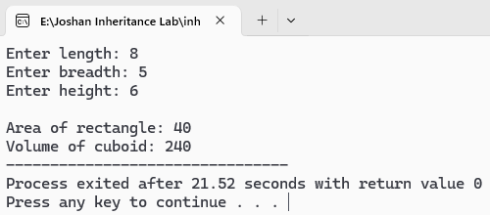

WAP to illustrate the order of constructor and destructor in inheritance.
43).
#include <iostream>
using namespace std;
class Base {
public:
Base() {
cout << "Base class constructor ." << endl;
}
~Base() {
cout << "Base class destructor ." << endl;
}
};
class Derived : public Base {
public:
Derived() {
cout << "Derived class constructor." << endl;
}
~Derived() {
cout << "Derived class destructor ." << endl;
}
};
int main() {
cout << "---Creating object..." << endl;
Derived obj; // object creation
cout << "----Object in use..." << endl;
return 0; // object destruction happens here
}
- Output:
